

King Fahd University of Petroleum & Minerals



Department of Information Systems & Operations Management

**Mis301**

**Team#3:**

Project title: Registration system for Dammam Community College

Prepared by:

Saleh Aljamea 201931910

Adi Sendi 201779270

Abdulmohsen Altamimi 202133490

Osama Alghamdi 201846580

Abdulrahman Alduhailan 201949150

Turki Harbi 201729530

Information System and Operation Management Department, King Fahd University of Petroleum and Minerals

MIS 301: Systems Analysis and Design  
  
Dr. Amine Nehari Talet

16th December 2022

Table of Contents

Table of Figure: 3

D1.1 Description 4

D1.2 Organizational Charts 5

D1.3 Feasibility Analysis 8

D2.1 Project plan: 11

D3.1 System proposal: 13

D3.2 System Request 15

D4.1 Use Case Analysis 16

D4.2 DFD: Data Flow Diagram 20

D4.3 ERD: Entity relation diagram 24

D4.4 Use Case Diagram: 29

D4.5 Data Dictionary 31

D4.6 User interface design: 35

D5.1 Conclusion: 41

Reference & Resource: 42

# Table of Figure:

Figure 1 (Dean organizational Chart) 6

Figure 2 (Registrar office Organizational chart) 7

Figure 3 (IT OFFICE ORGANIZITIONAL CHART) 8

Figure 4 (Cash Flow Diagram) 11

Figure 5 (Gantt Chart) 13

Figure 6 (Context Diagram) 23

Figure 7 (Level 0) 24

Figure 8 (level 1.1) 25

Figure 9 (Level 2.1) 25

Figure 10 (ERD 1NF) 26

Figure 11 (2NF) 27

Figure 12 (3NF) 29

Figure 13 (Use Case Diagram) 32

Figure 14 (Request Petition ) 37

Figure 15 (Request Petition 2) 38

Figure 16 (View Schedule) 39

Figure 17 (Add/Drop Course) 40

Figure 18 (Dropped Course Econ301) 41

Figure 19 (Select Term) 42

# D1.1 Description

Improving registration system for students at Dammam Community College to help the college administration system, the Student Registration & Admission Management module enables the college to handle the admission inquiries, track application status, centralize data management, develop efficient communication, and simplify time-consuming admission process with simplicity. We have worked as a group with the registrar MR. Ovais Khan of DCC in-person meeting, also we have communicated online with him. Utilizing this program, you may automate the admissions process to improve its effectiveness and efficiency. In their old system the most important thing for the user which is the UI was not that appealing, petitions were manual, there was no waitlist option to register courses, no added visual table of courses registered, also no CRNs to their sections and no documentation. The registration system is the backbone of every university or college, if it is not completed efficiently the whole system will collapse. An organized, efficient, and effective registration system for DCC is the target of our project, so students, the registration office and the college would benefit from it.

# D1.2 Organizational Charts

**1-Dean organizational Chart**

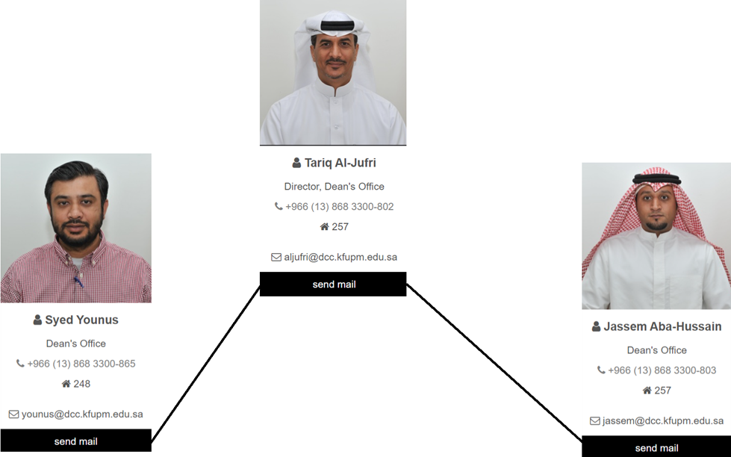

Figure 1 (Dean organizational Chart)

**2-Registrar office Organizational chart**

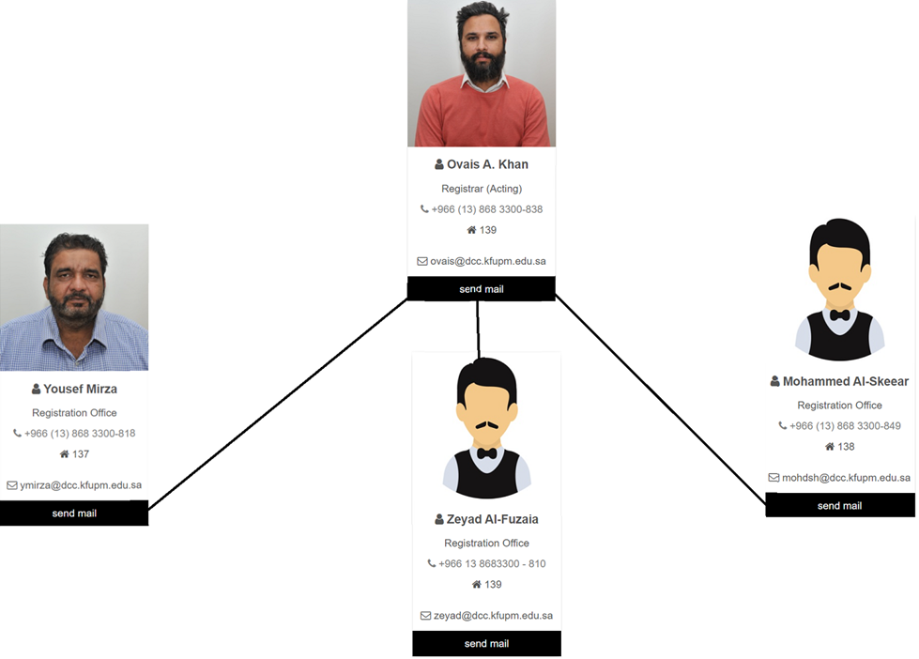

Figure 2 (Registrar office Organizational chart)

**3-IT OFFICE ORGANIZITIONAL CHART**



Figure 3 (IT OFFICE ORGANIZITIONAL CHART)

# D1.3 Feasibility Analysis

Feasibility Analysis seeks to fairly and logically weigh the advantages and disadvantages of a current or proposed business, risks associated with the endeavor, the resources needed to carry out operations, and eventually the likelihood of success.

|  |  |
| --- | --- |
| Technical Feasibility:  Can we build it? | The college is familiar with the application and the technology because they have the database and a current system, and the purpose is to improve the system. The project size will be low due to the high familiarity, and it is easy to integrate with the current system. |
| Economic Feasibility:  Should we build it? | The development cost will be low since it’s just improving not building from scratch, the project cost will be for the development team and the software. Also, the operational cost will be for the maintenance and will be considered normal to the usual cost of the operational cost of the current system. |
| Organizational Feasibility:  If we build it, will they come? | The project is highly aligned with the fundamental business system because it will upgrade the current system to achieve the enhancement. The project champion is highly supporting the project. The users who will benefit from the project are the administration, advisors, and students. |
| Recommendations | We recommend that the college proceeds to work on our system because it has a solid base that they can improve the registration system. |

**Cash Flow Diagram**

Cash flow Diagram Visually depict the flow of income and outgoings over a period of time. A horizontal line with markers placed at various time intervals makes up the diagram. Costs and expenses are displayed as needed.

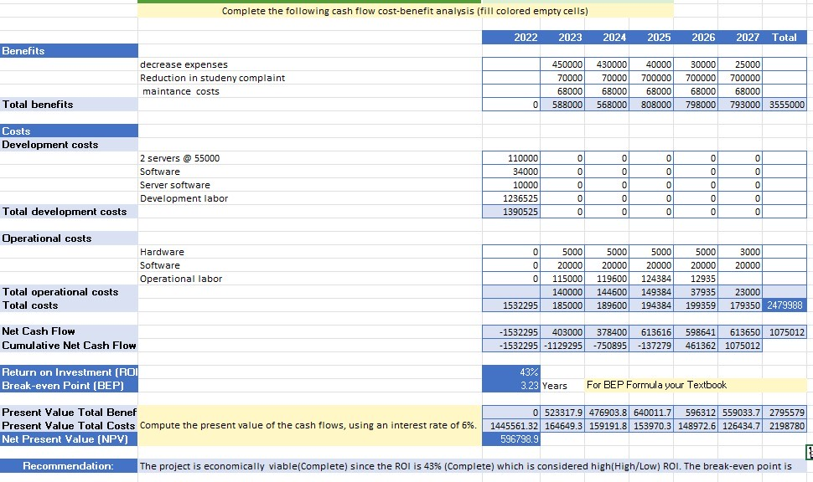

Figure 4 (Cash Flow Diagram)

# D2.1 Project plan:

**Gantt Chart**

Gantt Chart assist teams in properly allocating resources and scheduling work around deadlines. They are also used as another tool used by project planners to keep an overview on their initiatives. They show, among other things, how dependent tasks, milestones, and tasks with different start and end dates relate to one another.

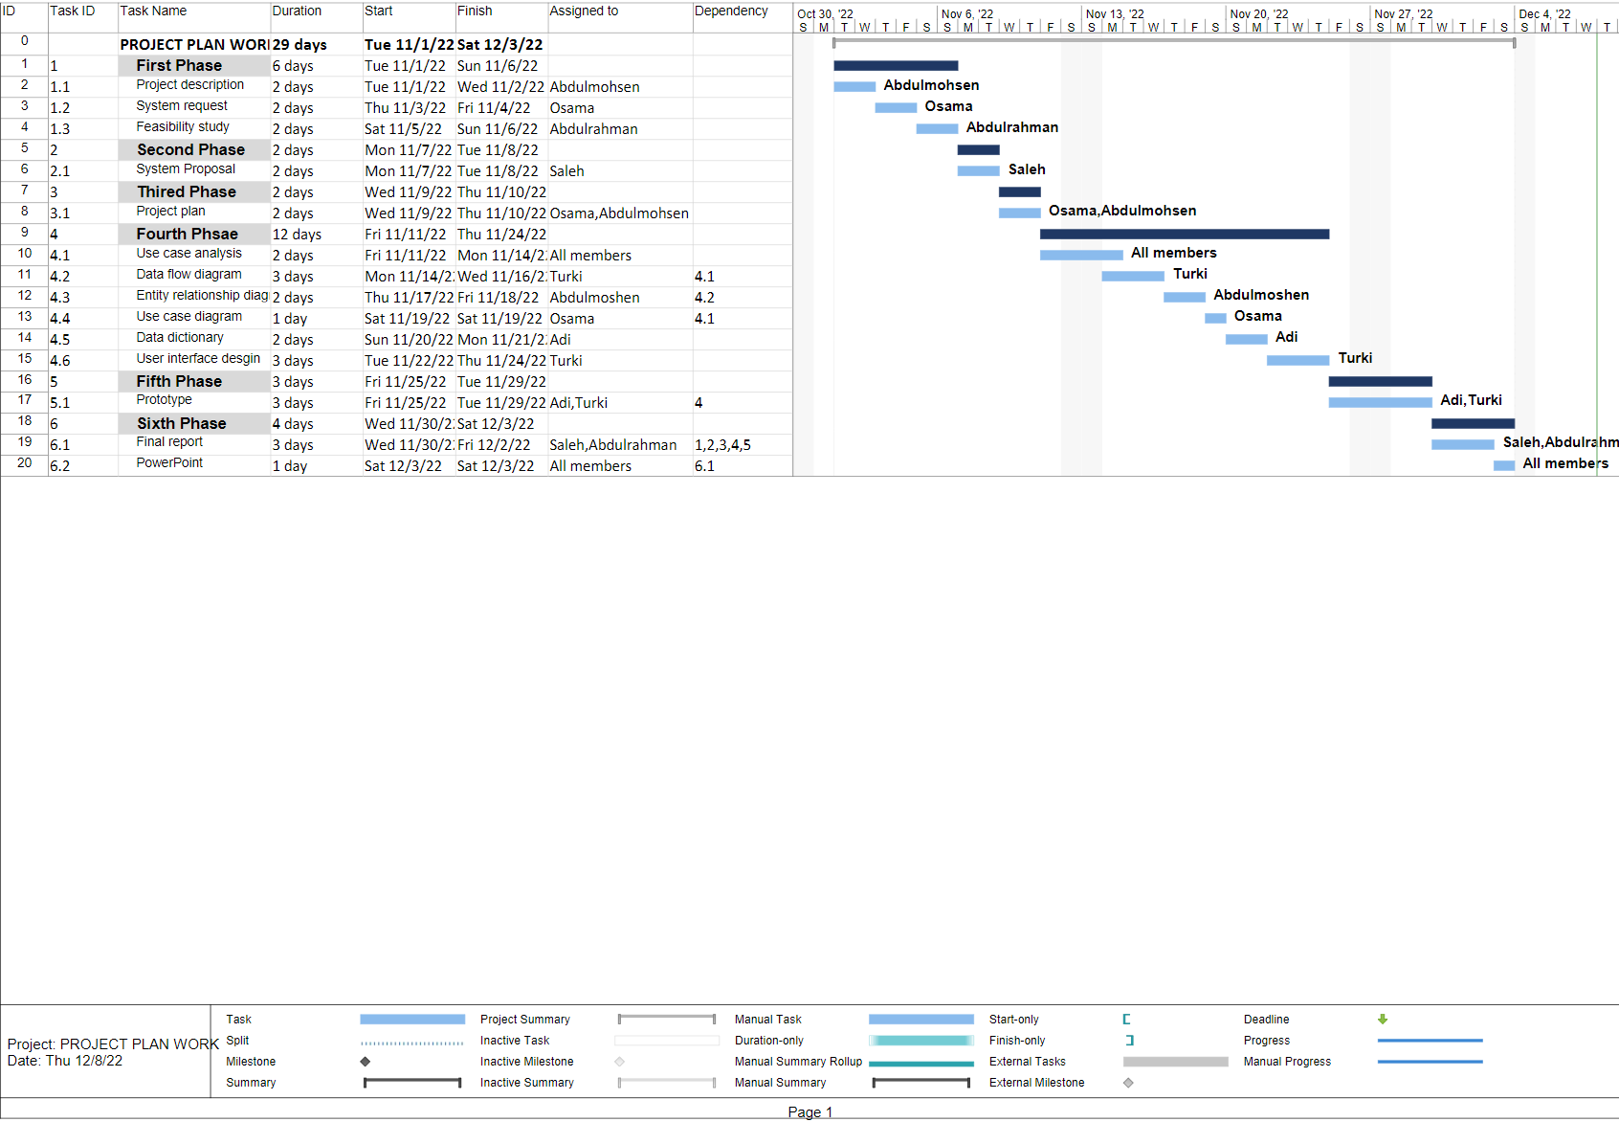

Figure 5 (Gantt Chart)

# D3.1 System proposal:

Project title: DCC Registration System

Project objectives:

Comparing a thorough online registration process to the "traditional" paper registration process, convenience and speed are the two most salient advantages. It is no longer necessary to manually fill out paper registration forms and mail them to a registration office thanks to online registration systems. The participants can easily register at their convenience and submit their information right away when using online registration tools. Without worrying about erasing or cutting, the participant can make any necessary adjustments. The participant's data will be loaded into a database right away. Adding the new features which are the improved user interface, and the online petition, Automated Registration processes and features, generating a visual schedule for the user, and improved documentation.

Comparison with Existing Similar Projects:

|  |  |  |  |  |
| --- | --- | --- | --- | --- |
|  | Our system | Old system | KFUPM system | KSU  system |
| Interface | medium | Very bad | good | Very good |
| Backend | good | bad | good | good |
| Reactive | medium | Very bad | bad | medium |
| Automated | good | bad | good | good |

Added Value:

Student engagement in registration will increase while reducing the paperwork that is being done in the registrar office. The system will be easier to navigate more “Usable”. Small details such as aesthetics are improved.

Stakeholders:

The most important stakeholder who have interest or concern in making the system better are the students, because they will interact with the system every semester. Advisors have also somewhat of a concern in the system being more efficient so they can finish their work on it faster and not to waist time on non-educational activities. Administration also has a stake in the system. Registration office plays the biggest rule on maintaining and presenting information from the system which they will have to document. DCC as a whole is a stakeholder in making this system operational, because as said before registration system is the backbone of every college or educational institution.

Targeted audience:

Students who are enrolled in the college and any user the interact with system, or anyone who interact with college.

Social Impact:

This strategy will ideally motivate more colleges to advance and encourage better websites. It will also support local growth and provide the kingdom a foothold in higher education while simultaneously competing with the big universities.

Additionally, we anticipate that the student will be more involved in the registration process.

# D3.2 System Request

System request is a document that outlines the business objectives behind the development of a system and the predicted benefits it will bring. as well as list’s the project's essential components.

|  |
| --- |
| System request - New Project |
| Project sponsor: (Job) Ovais Khan  Dammam Community College (DCC) |
| Business Need:  To enhance the current system while improving the students experience with Section registration  with also Improving access to information for both the registration department and the whole college. |
| Business Requirements:  Developing a modern interface to Automate the registration process, furthermore students can request a petition from the registration system and showing information about the Section for the students and faculty maintaining a useable (easy to use, easy to learn) system. |
| Business Value:  Increase the number of participation students in the registration while reducing the delay which will be a result of Improving the simplicity of the system |
| Special Issues or Constraints:  The limited time for finishing the project before the deadline (beginning of the next semester),  also connecting the advisor with the system. |

# D4.1 Use Case Analysis

Use Case Analysis is the main method for acquiring use specifications for a new piece of software or project.Use case analysis' main objectives are to identify all externally visible behaviors, build a system from the user's point of view, and communicate system behavior in user terms.

|  |  |  |  |
| --- | --- | --- | --- |
| Use Case Name: Register or Drop Section | | ID: uc-1 | Importance Level: High |
| Primary Actor: Student | | | |
| Short Description: a system to let the student register or drop their Section | | | |
| Trigger: Section to be added to the students or dropping unwanted Section  Type: External | | | |
| Major Inputs:  Description Source:    Student information Student Database  Section information Section Database  Register or drop request Student | Major Outputs:  Description Destination  Student information Student Database  Update database Section Database | | |
| Major Steps Performed   1. The request for register or drop Section comes from the student. 2. The system registers or drops the Section. 3. System update student and Section databases. | Information for Steps  1- Student GPA  2- Student Load  3- Student Status  4- Restriction  5- Section information  6-Students schedule | | |

|  |  |  |  |
| --- | --- | --- | --- |
| Use Case Name: ElectronicPetitions | | ID: uc-4 | Importance Level: Moderate |
| Primary Actor: Student | | | |
| Short Description: Students who had difficulties registering, would need approval to register | | | |
| Trigger: A student wanting to pass the restriction of a Section  Type: External | | | |
| Major Inputs:  Description    Student Information Student database  Request petition Student  Section information Section database  E-Petition result Registrar Office | Major Outputs:  Description: Destination:  Send petition Registrar Office  Update student Student database  Update Section Section database  Send rejected Student | | |
| Major Steps Performed   1. Student applies for e-petition 2. Student enters his information and the justification 3. The request goes to the registrar office to decide to accept or reject 4. If accepted the process will update the Section database and student database. If rejected the process will inform the student | Information for Steps  1- Section details  2- Added Section entry  3- Request Details  4- Student Details  5-request id number  6-petition type | | |

|  |  |  |  |
| --- | --- | --- | --- |
| Use Case Name: Register Waitlist | | ID: uc-3 | Importance Level: High |
| Primary Actor: Student | | | |
| Short Description: A system to enroll a student when a Section is full seats and reserve a waiting seat until there is a free seat. | | | |
| Trigger: Students to enroll when the Section is full seats  Type: External | | | |
| Major Inputs:  Description Source:    Request waitlist Student  Section information Section Database | Major Outputs:  Description Destination  Inform student Student  Update database Section database | | |
| Major Steps Performed   1. Students try to register a Section and find out that the Section are full seats 2. Students reserve a seat by registering the Section in the waitlist 3. If the Section seats got expanded the system will inform the student who is on the waitlist to register for the Section and reserve the seat for him in the system | Information for Steps    1-Student information  2-Degree plan  3- Section information | | |

|  |  |  |  |
| --- | --- | --- | --- |
| Use Case Name: Create or Delete Section | | ID: uc-2 | Importance Level: High |
| Primary Actor: Registrar Office | | | |
| Short Description: Allows departments to add or delete sections | | | |
| Trigger: Department want to add or delete section  Type: External | | | |
| Major Inputs:  Description Source  Section to be added or deleted Registrar Office | Major Outputs:  Description: Destination  Update database Section Database | | |
| Major Steps Performed   * The registrar receives the request of the creating or deletion of the section from the registrar office * The system creates or delete the section to the Section database | Information for Steps  1- Section name  2- Section number  3- Section status  4- Section available seats/ | | |

# D4.2 DFD: Data Flow Diagram

Data Flow Diagram is a graphical or visual representation that describes a business's operations through data movement using a standardized set of symbols and notations.

In formal methodologies like the Structured Systems Analysis and Design Method, they are frequently included.

*Context Diagram:*

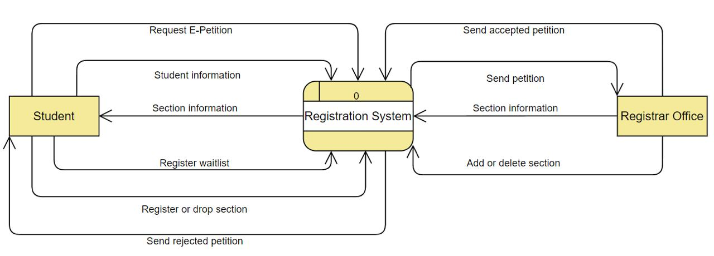

Figure 6 (Context Diagram)

*Level 0:*

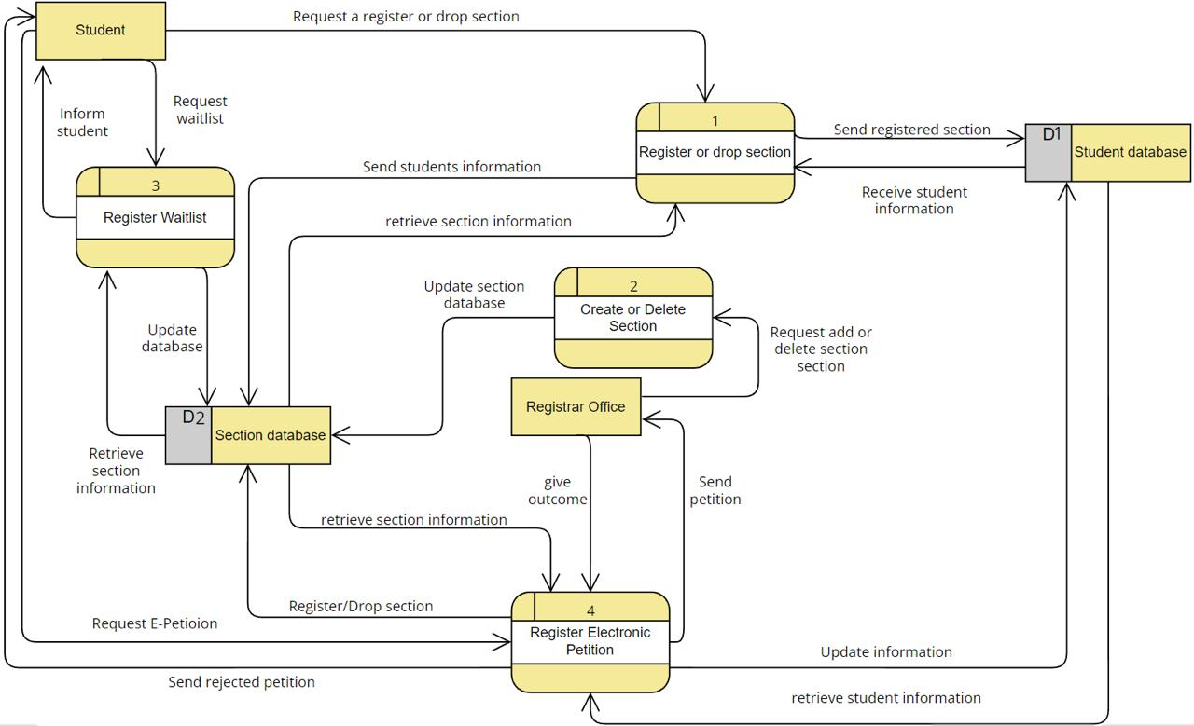

Figure 7 (Level 0)

*Level 1:*

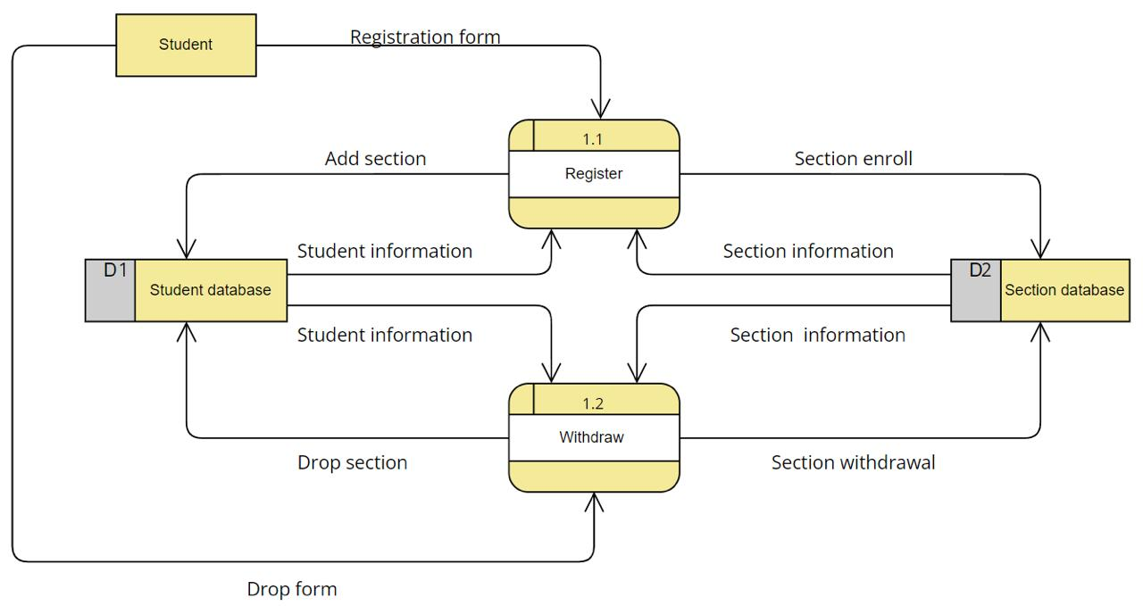

Figure 8 (level 1.1)

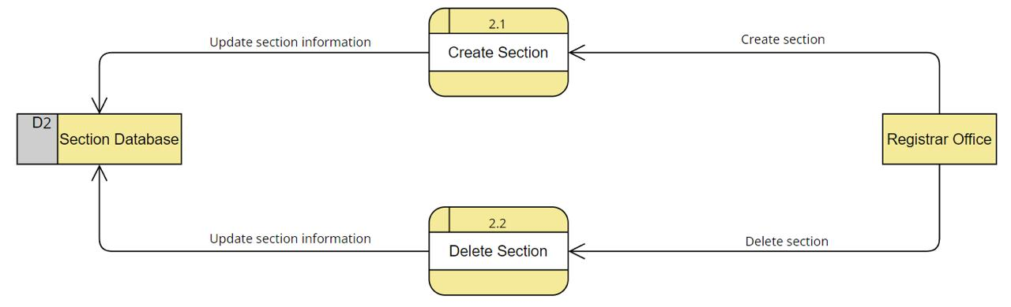

Figure 9 (Level 2.1)

# D4.3 ERD: Entity relation diagram

Entity relation diagram refers to the databases' tables. Attributes, which are the traits or qualities that make up entities. A primary key, which identifies a singular attribute, or a foreign key, which can be applied to several attributes, are two ways to refer to an ERD attribute. The connections and interactions between those things.

*1NF*

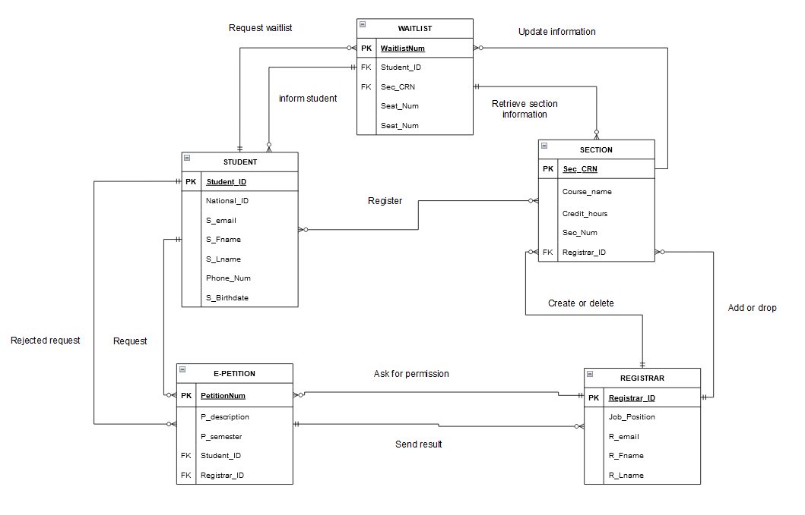

Figure 10 (ERD 1NF)

2NF

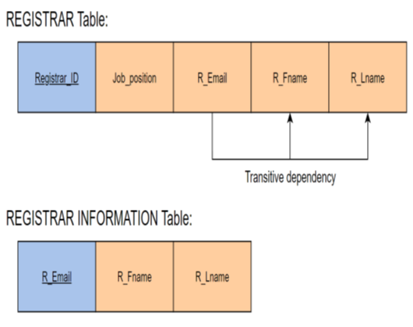

Figure 11 (2NF)

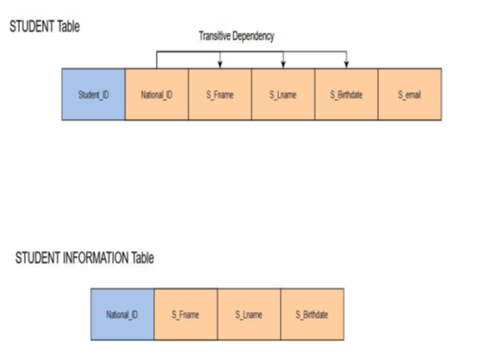

*3NF*

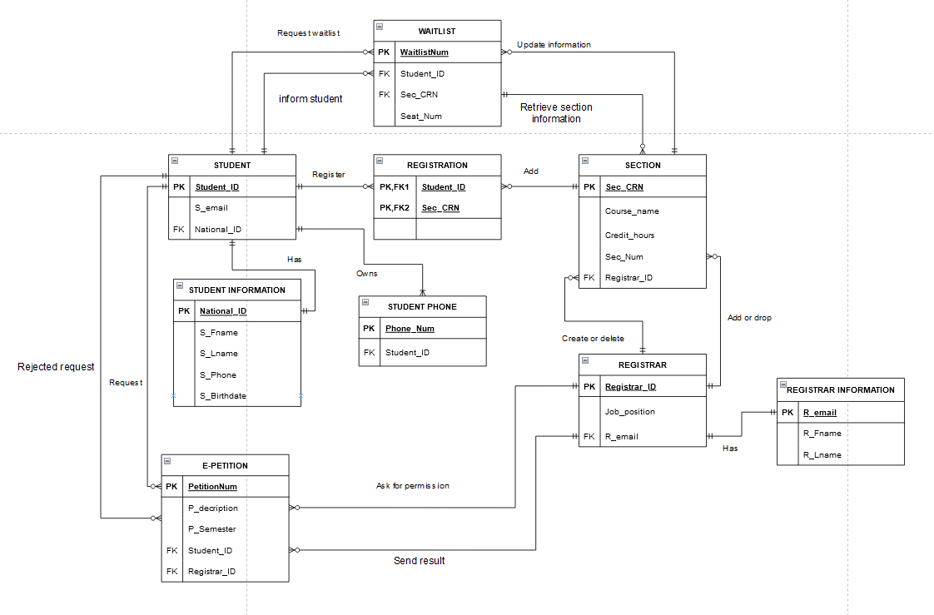

Figure 12 (3NF)

**Business rule:**

Business rules typically specify explicit guidelines or requirements for how certain routine tasks should be carried out.

Business regulations, for instance, could be:

a system for processing invoices that allows only particular managers to approve invoices up to a given amount.

1. Each STUDENT can request zero or many WAITLIST.
2. Each STUDENT can have zero or many SECTION.
3. A STUDENT can have one and only one NATIONAL ID.
4. Each STUDENT can request for zero or many E-PETITION.
5. Each STUDENT can be informed by zero or many WAITLIST.
6. Each STUDENT can be informed by zero or many E-PETITION.
7. Each WAITLIST belongs to one and only one STUDENT.
8. Each WAITLIST belongs to one and only one SECTION.
9. Each WAITLIST informs one and only one STUDENT.
10. Each WAITLIST receives information from one and only SECTION.
11. A NATIONAL ID belongs to one and only one STUDENT.
12. An E-PETITION belongs to one and only one STUDENT.
13. Each E-PETITION goes to one and only one REGISTRAR.
14. Each E-PETITION sends the rejection to one and only one STUDENT.
15. Each E-PETITION receives the result from one and only one REGISTRAR.
16. Each REGISTRAR can receive zero or many E-PETITION.
17. Each REGISTRAR can modify zero or many SECTION.
18. Each REGISTRAR can approve to add or drop a student from zero or many SECTION.
19. Each REGISTRAR can send the result to zero or many E-PETITION.
20. Each SECTION can have zero or many STUDENT.
21. Each SECTION can receive zero or many WAITLIST.
22. A SECTION modified by one and only one REGISTRAR.
23. A SECTION approves student by one and only one REGISTRAR.
24. Each SECTION can send information to zero or many WAITLIST.

# D4.4 Use Case Diagram:

Use Case Diagram describe the system's main features and scope.

The interactions between the system and its actors are also depicted in these diagrams.

Utilize-case diagrams show what the system does and how the actors use it, but they do not show how the system works within.

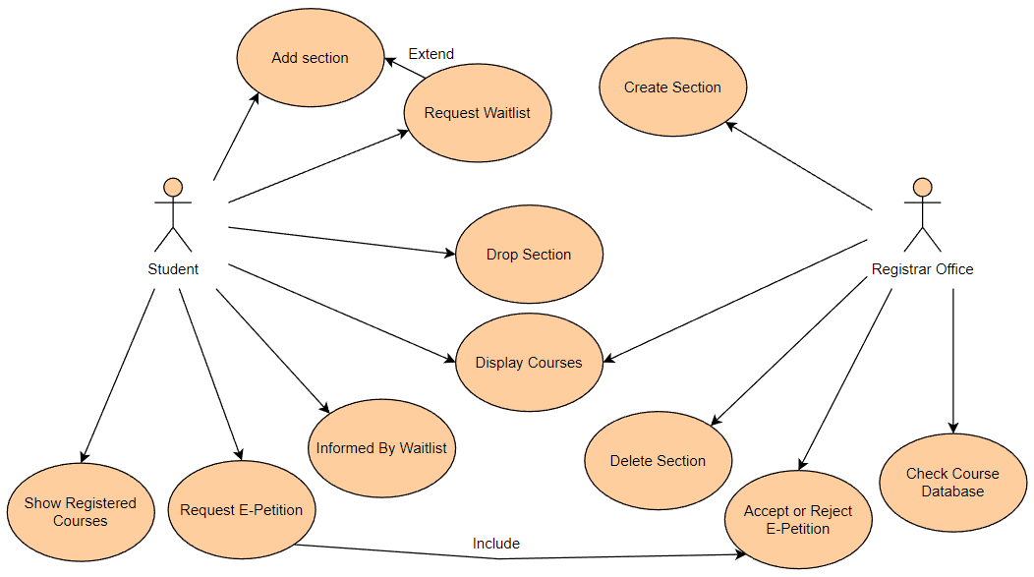

Figure 13 (Use Case Diagram)

# D4.5 Data Dictionary

Data Dictionary is employed to describe and explain the organization and substance of data, and it gives accurate descriptions for each named data object.

|  |  |  |  |  |  |  |  |  |  |
| --- | --- | --- | --- | --- | --- | --- | --- | --- | --- |
| Entity Name/Table name | Entity definition | Attribute name | Definition | Data Type | | Attribute type | | Required value | |
| REGISTRAR | A person who adds or drops sections and creates or deletes section | REGISTRAR_ID | Registrar’s unique identifier | | Number | | Primary key | | Yes | |
|  |  | Jop_position | Registrar job position | Character/text | | Regular | | Yes | |
|  |  | R_email | Registrar email | Character/text | | Regular | | Yes | |

|  |  |  |  |  |  |  |  |  |  |
| --- | --- | --- | --- | --- | --- | --- | --- | --- | --- |
| Entity Name/Table name | Entity definition | Attribute name | Definition | Data Type | | Attribute type | | Required value | |
| SECTION | A place where multiple student register to | SEC_CRN | Section’s unique identifier | | Number | | Primary key | | YES | |
|  |  | Course_name | Course name | Character/text | | regular | | YES | |
|  |  | Credit_hours | Course credit hours | Number | | regular | | YES | |
|  |  | Sec_num | Section number | Number | | regular | | YES | |
|  |  | Registrar_ID | Patient address | Number | | Foreign key | | YES | |

|  |  |  |  |  |  |  |  |  |  |
| --- | --- | --- | --- | --- | --- | --- | --- | --- | --- |
| Entity Name/Table name | Entity definition | Attribute name | Definition | Data Type | | Attribute type | | Required value | |
| Registrar information | Registrar personal information | R_email | Registrar information’s unique identifier | | Character/text | | Primary key | | YES | |
|  |  | R_Fname | Registrar first name | Character/text | | regular | | YES | |
|  |  | R_Lname | Registrar last name | Character/text | | regular | | YES | |

|  |  |  |  |  |  |  |  |  |  |
| --- | --- | --- | --- | --- | --- | --- | --- | --- | --- |
| Entity Name/Table name | Entity definition | Attribute name | Definition | Data Type | | Attribute type | | Required value | |
| Waitlist | A place where students take a number and wait in | WaitlistNum | Waitlist’s unique identifier | | Number | | Primary key | | YES | |
|  |  | Seat_Num | Number of the seat the student took | Number | | Regular | | YES | |
|  |  | SEC_CRN | Section’s unique identifier | Number | | Foreign key | | YES | |

**Required value  Attribute type  Data Type  Definition  Attribute name**

|  |  |  |  |  |  |  |  |  |  |
| --- | --- | --- | --- | --- | --- | --- | --- | --- | --- |
| Entity Name/Table name | Entity definition | Attribute name | Definition | Data Type | | Attribute type | | Required value | |
| Student phone | Student personal phone number | Phone_num | Student phone’s unique identifier | | Number | | Primary key | | Yes | |
|  |  | Student_ID | Student id number | Number | | Foreign key | | Yes | |
|  |  |  |  |  | |  | |  | |

**Entity definition  Entity Name/Table name**

|  |  |  |  |  |  |  |  |  |  |
| --- | --- | --- | --- | --- | --- | --- | --- | --- | --- |
| Entity Name/Table name | Entity definition | Attribute name | Definition | Data Type | | Attribute type | | Required value | |
| Student | A person who attends DCC | Student_id | Student’s unique identifier | | Number | | Primary key | | Yes | |
|  |  | S_email | Student e_mail | Character/text | | Regular | | Yes | |
|  |  | National_ID | Student national id | Character/text | | Foreign key | | Yes | |

|  |  |  |  |  |  |  |  |  |  |
| --- | --- | --- | --- | --- | --- | --- | --- | --- | --- |
| Entity Name/Table name | Entity definition | Attribute name | Definition | Data Type | | Attribute type | | Required value | |
| Student information | Information about the student | National_id | Student’s unique identifier | | Number | | Primary key | | Yes | |
|  |  | S_Fname | Student first name | Character/text | | Regular | | Yes | |
|  |  | S_Lname | Student last name | Character/text | | Regular | | Yes | |
|  |  | S_birthdate | Student date of birth | Date | | Regular | | Yes | |

|  |  |  |  |  |  |  |  |  |  |
| --- | --- | --- | --- | --- | --- | --- | --- | --- | --- |
| Entity Name/Table name | Entity definition | Attribute name | Definition | Data Type | | Attribute type | | Required value | |
| E-petition | Student who create e-petition | PetitionNum | Petition’s unique identifier | | Number | | Primary key | | Yes | |
|  |  | P_description | Description of the petition request | Character/text | | Regular | | Yes | |
|  |  | P_semester | Term number | Character/text | | Regular | | Yes | |
|  |  | Student_id | Student unique id | Character/text | | Regular | | Yes | |
|  |  | Registrar_id | Registrar unique id | Character/text | | Regular | | Yes | |

|  |  |  |  |  |  |  |  |  |  |
| --- | --- | --- | --- | --- | --- | --- | --- | --- | --- |
| Entity Name/Table name | Entity definition | Attribute name | Definition | Data Type | | Attribute type | | Required value | |
| Registration | Associated table between section and student | Student_id | Foreign and primary key for registration | | Number | | Primary & foreign key | | Yes | |
|  |  | Sec_CRN | Foreign and primary key for registration | Number | | Primary & foreign key | | Yes | |

# D4.6 User interface design:

User interface design is employed to describe and explain the organization and substance of data, and it gives accurate descriptions for each named data object.

***Request Petition (1):***

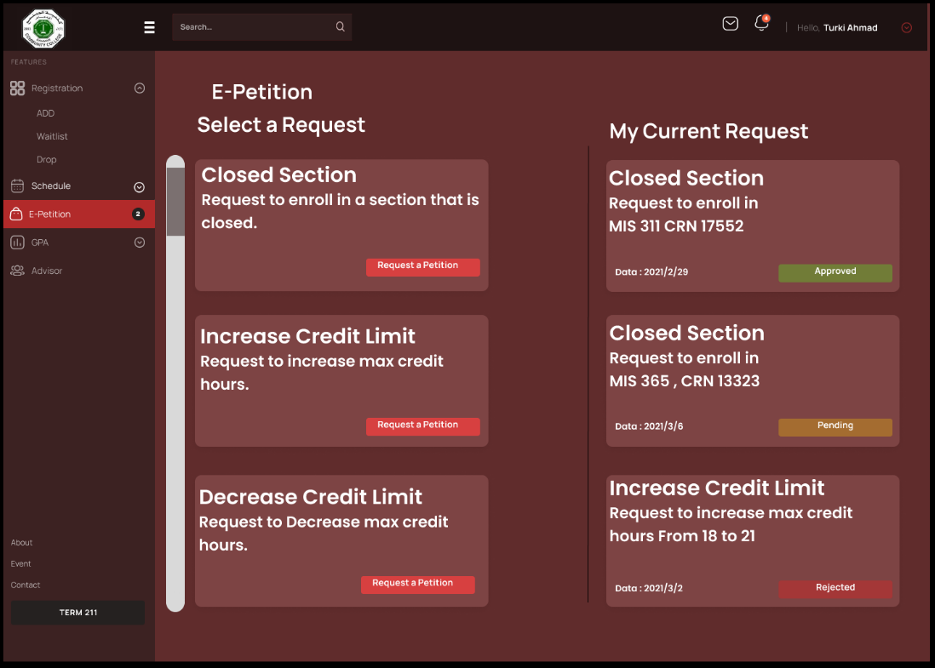

Figure 14 (Request Petition )

***Request Petition (2):***

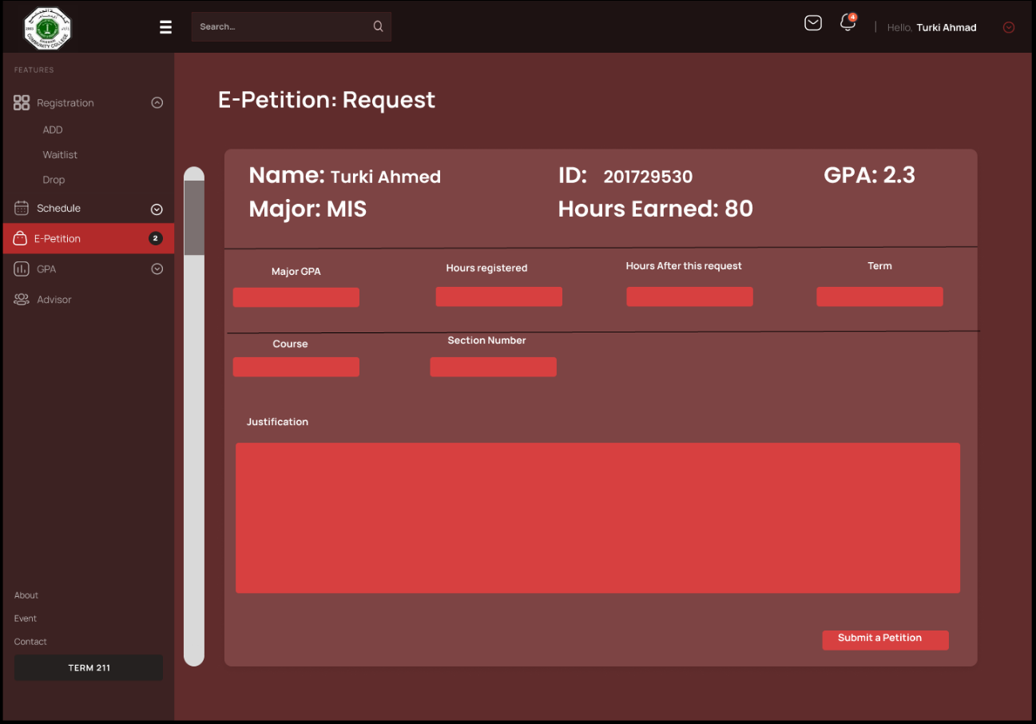

Figure 15 (Request Petition 2)

***View Schedule:***

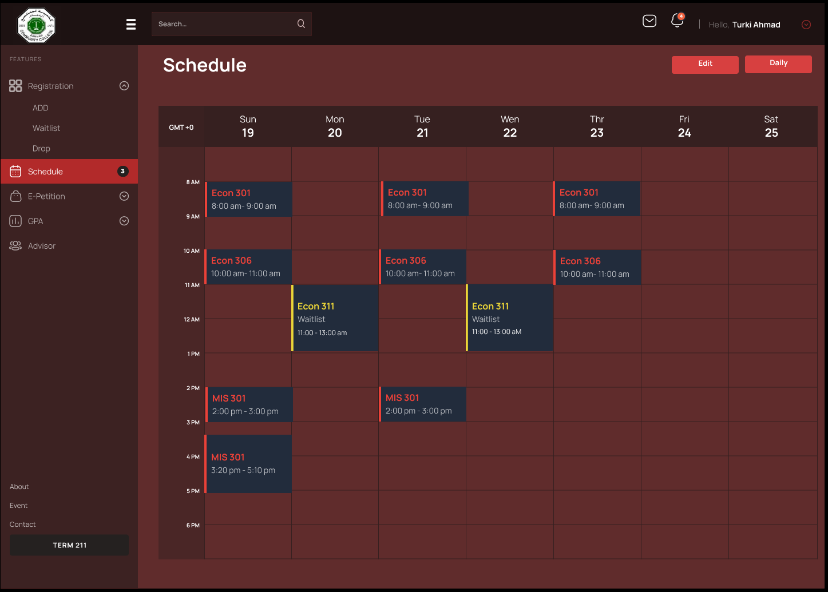

Figure 16 (View Schedule)

***Add/Drop Course***

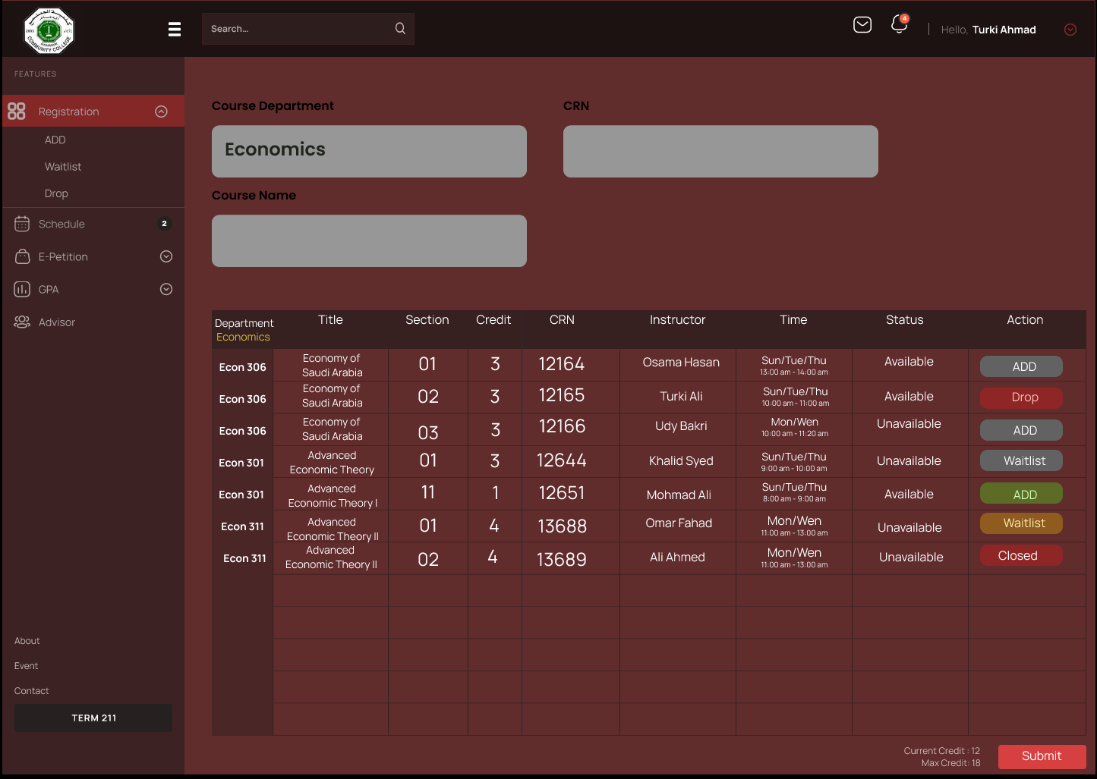

Figure 17 (Add/Drop Course)

***Dropped Course Econ301***

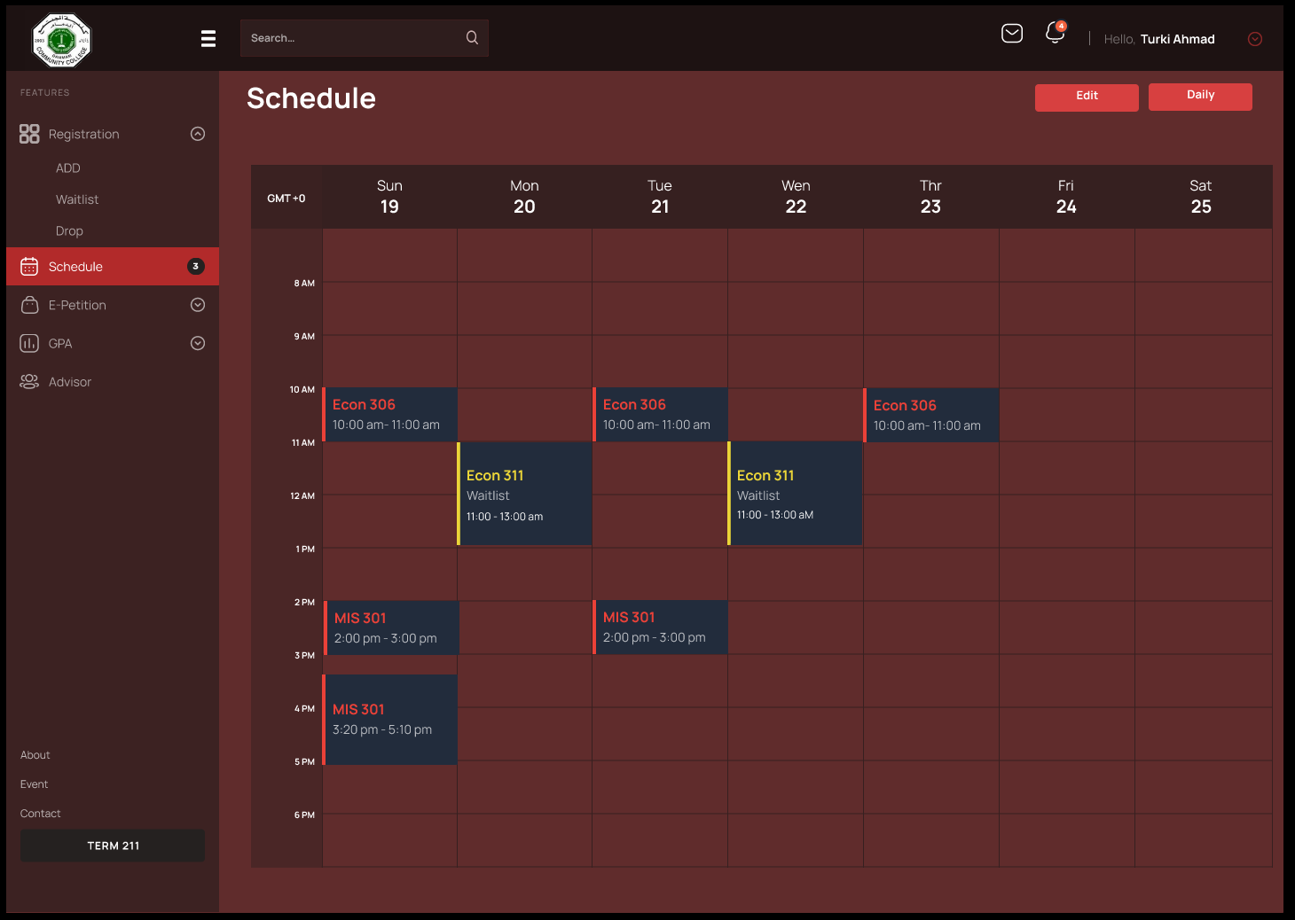

Figure 18 (Dropped Course Econ301)

***Select Term***

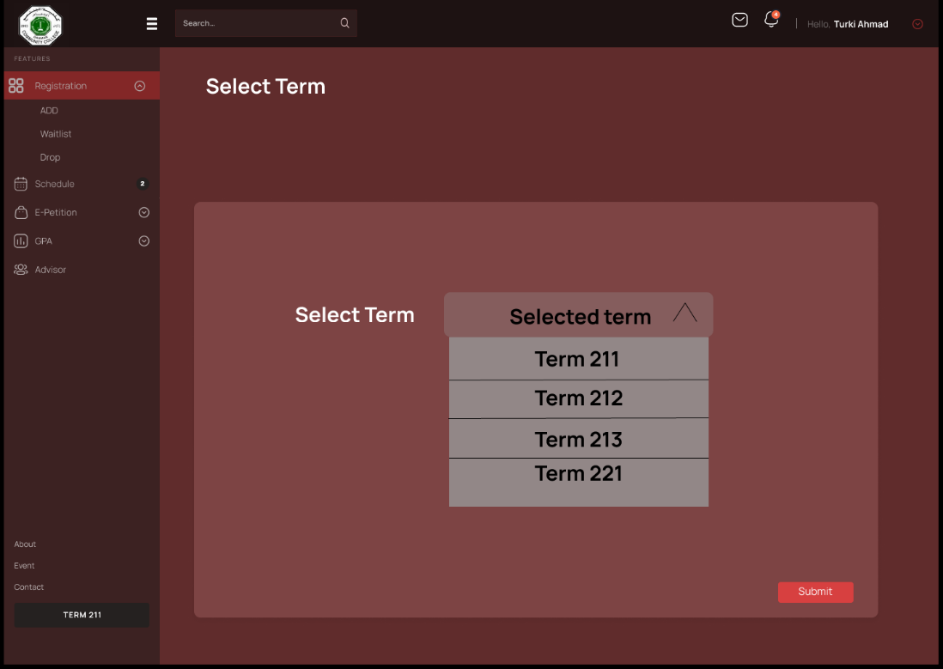

Figure 19 (Select Term)

Project Link:

<https://www.figma.com/file/KfBauicwJH78sQhBTDJauO/dashboard?node-id=0%3A1&t=gZRGXfjm0tH7do6Y-0>

Demo Link:

https://kfupmedusa.sharepoint.com/:v:/r/sites/MIS301G4/Shared%20Documents/General/Recordings/Meeting%20in%20_General_-20221209_200807-Meeting%20Recording.mp4?csf=1&web=1

# D5.1 Conclusion:

In conclusion our project objective focused on upgrading the original DCC registration system to make it a more usable system for all who are involved. Automation of the functions of the system which are made manually today are hoped to be eliminated from their system, reducing the duration, and making it as efficient as possible was the goal. We have added some features which are necessary for the registration system. DCC registrar welcomed our efforts and suggestion to improve their system by adding these features. The first feature to consider are the functional requirements, adding CRNs to sections is crucial, adding waitlist options has been done to rise students' chance to register courses, and it is also helpful for the department and the registrar so they could know the number of students who want to register in a section. Petitions are automated which will help to make the process faster and easier, for example now if a student wants to register in a closed section they can through the system. User Interface has been developed to make the system more interactive for the user. A table for the schedule has been added to the system. A better back end and documentation are improved to reduce individual mistakes. We have improved our communication skills through communicating with Mr. Ovais Khan, we also gained professional knowledge on how to work as a team which will be helpful for all of us in the future. Learning how to make our first project and its important elements, which are the system request and the feasibility analysis and making the project plan through Microsoft Project, also making the use cases and the DFD and ERD, acquired knowledge on how to develop the data dictionary and the use case diagram, and most importantly making the prototype and the user interface design.

# Reference & Resource:

Dennis, A., Wixom, B. H., & Roth, R. M. (2014). *Systems Analysis and Design* (6th ed.). Wiley.

Shneiderman, B., Plaisant, C., (2010). *Designing the User Interface* (6th ed). Wesley.

*Figma: the collaborative interface design tool.* (n.d.). Figma. <https://www.figma.com>.

*Data Flow Diagram Online | DFD Maker | Tips and Templates | Creately*. (2021, November 2). <https://creately.com/lp/data-flow-diagram-software-online/>.

*draw.io*. (n.d.). https://www.draw.io/connect/office365/index.html.

*Dammam Community College*. (2003, January 1). Retrieved January 1, 2008, from <https://www.dcc.kfupm.edu.sa/>.